The DLL Class
(Circular, Doubly Linked Lists)

Of all the species of linked lists, the circular, doubly linked list with a dummy head node is the most powerful. In this lab we make such a class and implement selected methods in Java's List interface and its LinkedList class. We will use Object, not <E>, as the values in each DLNode.
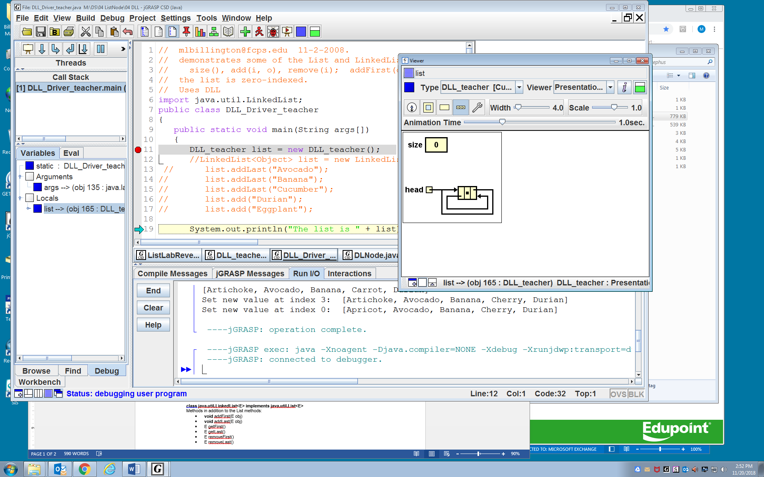
A DLNode object has a private field holding an object, a prev pointer, and a next pointer. In a default DLNode object, the prev and the next both point to this.

The DLL class has two private fields, one of which points to a DLNode object. This DLNode is a dummy node, meaning that it is always present, does not store data, and whose only purpose is to simplify the insertion and deletion operations; specifically, one item of data is no longer a special case. Notice the two private fields in the DLL object named myList below.
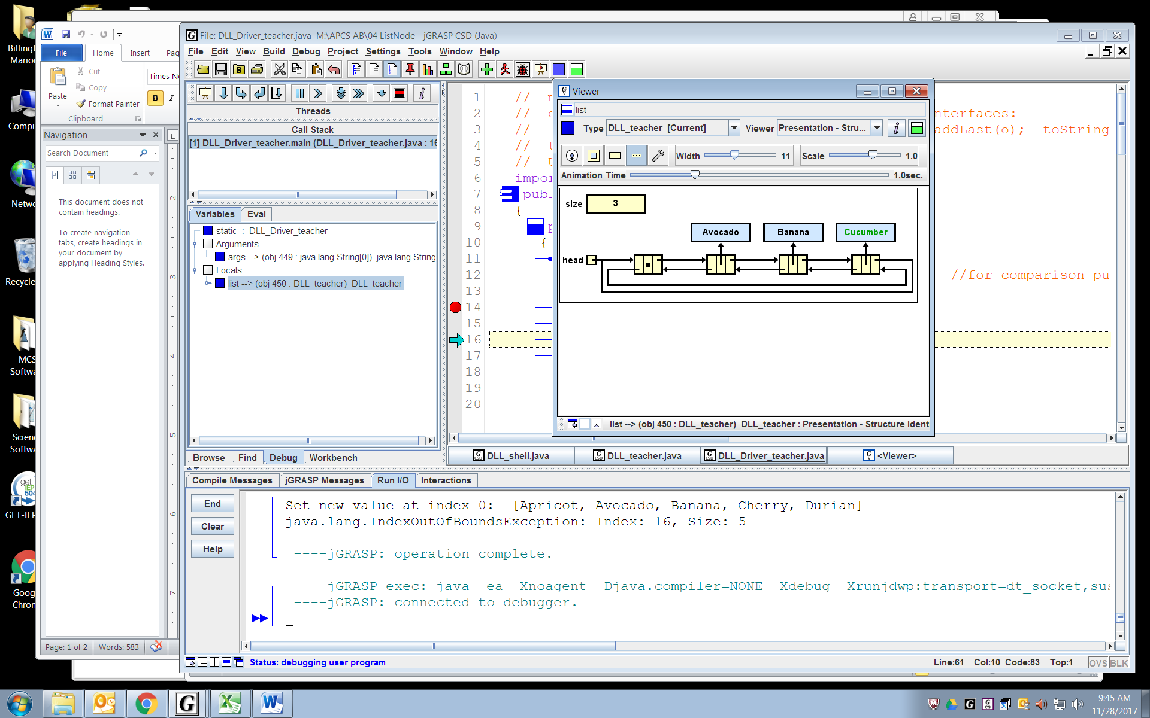
DLL myList

Implement the methods for this data structure (using Object instead of <E>) as specified in the two College Board interfaces below. Also write a toString method, so that the list can print itself with commas and square brackets. For example, System.out.println(myList) outputs [Avocado, Banana, Cucumber]

As you write each method, test it in a driver class to see that it actually works. If you are using JGrasp, setting a breakpoint and stepping through the action can be quite instructive.

interface java.util.List<E>
- int size()
- boolean add(E obj) // appends obj to end of list; returns true
- void add(int index, E obj) // inserts obj at position index (0 <= index <= size)
// moving elements at position index and higher
// to the right (adds 1 to their indices); adjusts size
- E get(int index)
- E set(int index, E obj) // replaces the element at index with obj
// returns the element formerly at index
- E remove(int index) // removes element from position index, moving
// elements at position index + 1 and higher to the
// left (subtracts 1 from their indices) and adjusts
// size; returns the element formerly at index
String toString()

class java.util.LinkedList<E> implements java.util.List<E>
Methods in addition to the List methods:
- void addFirst(E obj)
- void addLast(E obj)
- E getFirst()
- E getLast()
- E removeFirst()
- E removeLast()

Assignment
The driver DLL_Driver is given to you. You are to complete the DLL class, which includes the code for DLNode. You will submit DLL.

class DLL //DoubleLinkedList
{ private int size = 0;
private DLNode head = new DLNode(); //dummy node--very useful--simplifies the code
public int size()
{
}
/* appends obj to end of list; increases size; @return true */
public boolean add(Object obj)
{
addLast(obj);
return true;
}
/* inserts obj at position index (the list is zero-indexed). increments size. */
public void add(int index, Object obj) throws IndexOutOfBoundsException
{
if( index > size || index < 0 )
throw new IndexOutOfBoundsException("Index: " + index + ", Size: " + size);

}
/* return obj at position index (zero-indexed). */
public Object get(int index) throws IndexOutOfBoundsException
{
if(index >= size || index < 0)
throw new IndexOutOfBoundsException("Index: " + index + ", Size: " + size);

}
/* removes the node from position index (zero-indexed). decrements size.
@return the object at position index (zero-indexed). */
public Object remove(int index) throws IndexOutOfBoundsException
{
if(index >= size || index < 0)
throw new IndexOutOfBoundsException("Index: " + index + ", Size: " + size);

}
/* appends obj to end of list; increases size */
public void addLast(Object obj)
{

}
//lots more methods in this class

